ArTech

Use Case Model

Usage note: There is procedural guidance within this template that appears in a style named InfoBlue. This style has a hidden font attribute allowing you to toggle whether it is visible or hidden in this template. Use the Word menu Tools🡪Options🡪View🡪Hidden Text checkbox to toggle this setting. A similar option exists for printing Tools🡪Options🡪Print.

# Introduction

Model use cases that we have in the system requested by the customer

# Overview

System for registering services, scheduling and technical users

# Use-Case Diagram

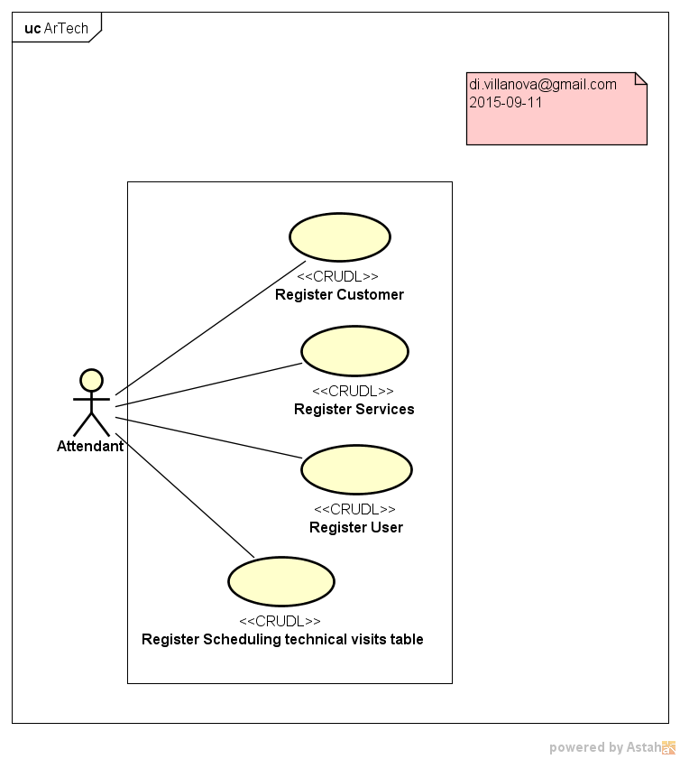

# Actors

Attendant

# Use Cases

**5.1 Register Customer**

Registers remove and edit clients.

**5.2 Register Services**

Registers remove and edit services.

**5.3 Register User**

Registers remove and edit users.

**5.4 Register scheduling technical visit table**

Registers remove and edit scheduling technical visit table.